Synopsis

Project Title

PBL AI-ML

Problem Id: 8

Student Name
Rishi Negi
Tushar Dagar
University Roll number
2510380076
2510385194
Section P

- Problem Description:
Banks need to decide whether to give loans to people. If they approve the wrong person, the bank may lose money because the person might not pay back (this is called a default). Doing this decision manually is slow and can be unfair. So, we want to build a machine learning pipeline that can automatically check applicants and predict whether they are “Approved” or “Default.”
We will use three main features:
Credit Score → shows how trustworthy the person is with money.
Annual Income → how much money they earn in a year.
Debt-to-Income Ratio → how much debt they already have compared to their income.
The problem is that in real life, very few people default compared to those who pay back. This makes the dataset imbalanced. To fix this, we use techniques like SMOTE (Synthetic Minority Oversampling Technique) or oversampling to add more “Default” examples.
Finally, we train a Logistic Regression model (a simple but powerful algorithm for yes/no decisions). We will check how well it works using metrics like F1-Score and Precision.
The goal is to make loan approvals faster, fairer, and safer for banks.

- Steps of Implementation:
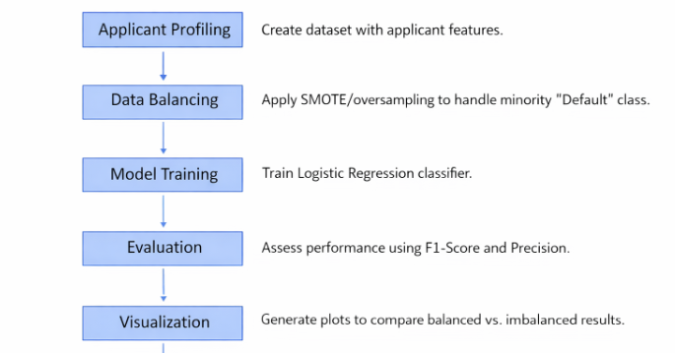

- Expected Modules/ Libraries to be used :
pandas – Data handling and preprocessing.
NumPy – Numerical computations.
scikit-learn – Logistic Regression, metrics, train-test split.
imblearn – SMOTE and oversampling techniques.
matplotlib / seaborn – Visualization of metrics and plots.

- Expected Evaluation metrics and Plots to be used:
F1-Score & Precision – To measure performance on imbalanced data.
Confusion Matrix – To visualize classification accuracy.
ROC Curve & AUC – To evaluate model discrimination ability.
Bar/Line Plots – To compare metrics before and after balancing.
- Required topics from the subject:
Strings
Strings in Python are used to store and manipulate text data. In this project, they can represent applicant names, loan status labels (“Default” / “Approved”), or categorical attributes for profiling.
Lists (Arrays equivalent)
Lists allow storage of multiple values in a single variable. They can hold applicant features such as credit scores or incomes, making iteration and preprocessing straightforward.
Files
File handling in Python (open(), read(), write()) enables saving datasets, loading applicant records, and exporting model predictions or evaluation results into CSV or text files.
Functions
Functions (def) modularize code into reusable blocks. For example, separate functions can be written for preprocessing, balancing, training, and evaluating the model pipeline.
Classes & Objects
Object-oriented programming in Python allows grouping related attributes and methods. An Applicant class could encapsulate features like credit score, income, and debt ratio, making the dataset more structured.
Modules & Libraries
Python’s standard and external libraries (e.g., pandas, numpy, sklearn) provide ready-made functions for data handling, model building, and evaluation, reducing development effort.
- Platform Required:
Visual studio / Python idle.
- Books and Link Sources:
Hands-On Machine Learning with Scikit-Learn, Keras, and TensorFlow – Aurélien Géron.
Pattern Recognition and Machine Learning – Christopher Bishop.
Introduction to Machine Learning with Python – Andreas Müller & Sarah Guido.
Online resource: Scikit-learn Documentation.

